Stated Subject

✅ What is Stated Subject
# Source: AI Source: Provided by: [Data Path: Persons Table -> ID Column: 1, Name_En Column: Motasem Essam] -> From: [Chatgpt (GPT-4-turbo)] on [8/4/2025]
A stated subject is a subject that is explicitly mentioned in the sentence, whether it’s a noun, pronoun, noun phrase, or clause.
It is the opposite of an implied subject (which is unstated but understood).

🔹 When Is It Used?
# Source: AI Source: Provided by: [Data Path: Persons Table -> ID Column: 1, Name_En Column: Motasem Essam] -> From: [Chatgpt (GPT-4-turbo)] on [8/4/2025]
- In declarative and interrogative sentences
- In non-imperative contexts where clarity is needed
- With third-person or specific subjects

🔹 Structure:
# Source: AI Source: Provided by: [Data Path: Persons Table -> ID Column: 1, Name_En Column: Motasem Essam] -> From: [Chatgpt (GPT-4-turbo)] on [8/4/2025]
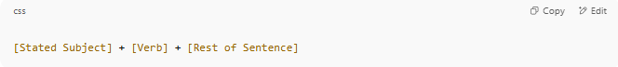
[Stated Subject] + [Verb] + [Rest of Sentence]

🔹 Examples:
# Source: AI Source: Provided by: [Data Path: Persons Table -> ID Column: 1, Name_En Column: Motasem Essam] -> From: [Chatgpt (GPT-4-turbo)] on [8/4/2025]
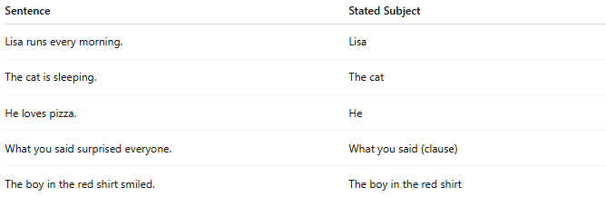
Sentence | Stated Subject
Lisa runs every morning. | Lisa
The cat is sleeping. | The cat
He loves pizza. | He
What you said surprised everyone. | What you said (clause)
The boy in the red shirt smiled. | The boy in the red shirt

🔍 Key Points:
# Source: AI Source: Provided by: [Data Path: Persons Table -> ID Column: 1, Name_En Column: Motasem Essam] -> From: [Chatgpt (GPT-4-turbo)] on [8/4/2025]
- May be simple (one word) or complex (phrase or clause)
- Can be a noun, pronoun, or even a clause
- Always visible in the sentence

